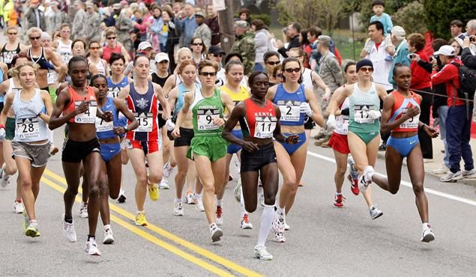
PEOPLE WHEN RUNING

